565 | SABAH KAHVALTISI/BREAKFAST | ÖĞLE YEMEĞİ/LUNCH | İKİNDİ KAHVALTISI/AFTERNOON SNACKS
03.04.2017 | HAŞLANMIŞ YUMURTA, SERPME KAHVALTI (peynir, zeytin, tahin-pekmez, bal ), SÜT/ BOILED EGGS, STANDARD BREAKFAST, MILK | TARHANA ÇORBA, ETLİ PATATES YEMEĞİ, AYRAN/ SOUP, ROUND AND FLAT BREAD WITH MEAT, AYRAN | HAVUÇLU KEK, SÜT/ CARROT CAKE, MILK
04.04.2017 | GÖZLEME ,SERPME KAHVALTI (peynir, zeytin, tahin-pekmez, bal,) SÜT/ PANCAKE, STANDARD BREAKFAST, MILK | ETLİ NOHUT YEMEĞİ, PİRİNÇ PİLAVI, SALATA/ CHICKPEAS WITH MEAT, RICE, SALAD | 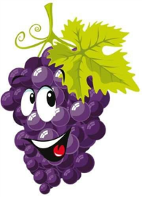  PİŞİ, AYRAN/ HOME-MADE PUFF PASTRY, AYRAN
05.04.2017 | OMLET,SERPME KAHVALTI (peynir,zeytin,tahin-pekmez,bal), SÜT/ OMELETTE, STANDARD BREAKFAST, MILK | ETLİ KARNABAHAR YEMEĞİ, BULGUR PİLAVI/ CAULI FLOWER WITH MEAT, RICE OF WHEAT GRAINS | ISLAK KURABİYE, BİTKİ ÇAYI/ WET COOKIE, HERBAL TEA
06.04.2017 | SÜTLÜ YUMURTA, SERPME KAHVALTI(peynir,zeytin,tahin-pekmez,bal), SÜT/ MILKY EGG, STANDARD BREAKFAST, MILK | KIYMALI BEZELYE YEMEĞİ, PİRİNÇ PİLAVI, AYRAN/ SWEET PEA WITH MEAT, RICE, AYRAN | MAKARNA SALATASI, MEYVE/ PASTA SALAD, FRUIT
07.04.2017 | FIRINDA EKMEK KIZARTMASI, HAŞLANMIŞ YUMURTA, SERPME KAHVALTI (peynir, zeytin, tahin-pekmez, bal) SÜT/ FRIED BREAD, BOILED EGG, STANDARD BREAKFAST, MILK | SALATA, PİZZA, AYRAN/ SALAD, PIZZA, AYRAN | BİSKÜVİLİ YAŞ PASTA, MEYVE/ WET CAKE, FRUIT
10.04.2017 | OMLET , SERPME KAHVALTI (peynir, zeytin, tahin-pekmez, bal) SÜT/ OMELETTE, STANDARD BREAKFAST, MILK | DALYAN KÖFTE, PATATES PÜRE, MAKARNA, HAVUÇ SALATASI/ MEATBALL, POTATO PUREE, PASTA, CARROT SALAD | 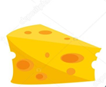  KANEPE, HAVUÇ, BİTKİ ÇAYI/ CANAPE, CARROT, HERBAL TEA
11.04.2017 | PATATESLİ YUMURTA, SERPME KAHVALTI (peynir,zeytin,tahin,pekmez,bal), SÜT/ POTATOES WITH SCRARNBLED EGGS, STANDARD BREAKFAST, MILK | YOĞURT ÇORBA, KIYMALI ISPANAK, ŞEHRİYE PİLAVI/ SOUP, SPINACH WITH MEAT, RICE |   PUDİNG, MEYVE/ PUDDING, FRUIT
12.04.2017 | SAHANDA YUMURTA, SİMİT , SERPME KAHVALTI (peynir, zeytin, tahin-pekmez, bal) SÜT/ FRIED EGGS, SIMIT, STANDARD BREAKFAST, MILK | EZOGELİN ÇORBA, FIRINDA KIYMALI PATATES OTURTMA, MEVSİM SALATA/ SOUP, BAKED POTATO WITH MEAT, SALAD | PİŞİ, AYRAN/ HOME-MADE PUFF PASTRY, AYRAN
13.04.2017 | FIRINDA EKMEK KIZARTMASI, HAŞLANMIŞ YUMURTA, SERPME KAHVALTI (peynir, zeytin, tahin-pekmez, bal) SÜT/ FRIED BREAD, BOILE EGGS, STANDARD BREAKFAST, MILK | GEZEN TAVUK SOTE, MAKARNA, YOĞURT/ ORGANIC CHICKEN, PASTA, YOGURT | KADAYIFLI MUHALLEBİ/ PUDDING
14.04.2017 | AÇMA, SÜTLÜ YUMURTA, SERPME KAHVALTI (peynir, zeytin, tahin-pekmez, bal) SÜT/ HOME-MADE PASTRY, MILKY EGGS, STANDARD BREAKFAST, MILK | KIRMIZI MERCİMEK ÇORBA, KOL BÖREĞİ(etli, peynirli) KOMPOSTO/ SOUP, ROLLED PASTRY(WITH MEAT AND CHEESE), COMPOSTE |   MERCİMEK KÖFTE, MANDALİNA, ELMA/ LENTIL BALLS, MANDARIN, APPLE
17.04.2017 | KAŞARLI TOST,SERPME KAHVALTI, SAHANDA YUMURTA,(peynir, zeytin, tahin-pekmez, bal) SÜT/ CHEESE TOAST, STANDARD BREAKFAST, FRIED EGGS, MILK | EKŞİLİ KÖFTE, BULGUR PİLAVI, YOĞURT/ MEATBALLS WITH RICE IN EGG AND LEMON SAUCE, RICE OF WHEAT GRAINS, YOGURT | MİLFÖY BÖREĞİ, MEYVE TABAĞI/ PUFF PASTRY, FRUIT PLATE
18.04.2017 | HAŞLANMIŞ YUMURTA, SERPME KAHVALTI (peynir, zeytin, tahin-pekmez, bal) SÜT/ BOILED EGGS, STANDARD BREAKFAST, MILK | KIYMALI SEMİZOTU, KUSKUS PİLAVI, CACIK/ PURSLANE WITH MEAT, KUSKUS, CUCUMBER YOGURT | KURABİYE, BİTKİ ÇAYI/ COOKIE, HERBAL TEA
19.04.2017 | TOST , HAŞLANMIŞ YUMURTA, SERPME KAHVALTI (peynir, zeytin, tahin-pekmez, bal,) SÜT/ TOAST, BOILED EGGS, STANDARD BREAKFAST, MILK | HAVUÇ ÇORBA, BEŞAMEL SOSLU KARNABAHAR YEMEĞİ, PİRİNÇ PİLAVI/ SOUP, CAULI FLOWER WIH BECHAMEL SAUCE, RICE | 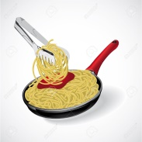  MİNİ POĞAÇA, SÜT/ HOME-MADE PASTRY, MILK
20.04.2017 | OMLET, SERPME KAHVALTI (peynir, zeytin, tahin-pekmez, bal) SÜT/ OMELETTE, STANDARD BREAKFAST, MILK | ETLİ KURU FASULYE YEMEĞİ, PİRİNÇ PİLAVI, CACIK/ WHITE BEANS WITH MEAT, RICE, CUCUMBER YOGURT | KISIR, BİTKİ ÇAYI/ BULGUR SALAD, HERBAL TEA
21.04.2017 | KIZARMIŞ EKMEK, SERPME KAHVALTI, SÜTLÜ YUMURTA (peynir, zeytin, tahin-pekmez, bal,) SÜT/ FRIED BREAD, STANDARD BREAKFAST, MILKY EGGS, MILK | ŞEHRİYE ÇORBA, SEBZELİ ET SOTE, SALATA/ SOUP, SAUTEED MEAT WITH VEGETABLES, SALAD | MİLFÖY BÖREĞİ, MEYVE/ PUFF PASTRY, FRUIT
24.01.2017 | FIRINDA KAŞARLI EKMEK, SERPME KAHVALTI (peynir, zeytin, tahin-pekmez, bal) BİTKİ ÇAYI/ BAKED BREAD WITH CHEESE, STANDARD BREAKFAST, HERBAL TEA | ET HAŞLAMA, MAKARNA, YOĞURT/ BOILED MEAT, PASTA, YOGURT | PEKMEZLİ UN HELVASI, MEYVE TABAĞI/ FLOUR HALVA WITH PEKMEZ, FRUIT PLATE
25.04.2017 | KREP, SERPME KAHVALTI (peynir, zeytin, tahin-pekmez, bal,), SÜT/ PANCAKE, STANDARD BREAKFAST, MILK | ETLİ ISPANAK, BULGUR PİLAVI, SALATA/ SPINACH WITH MEAT, RICE OF WHEAT GRAINS, SALAD | KURABİYE, MEYVE TABAĞI/ COOKIE, FRUIT PLATE
26.04.2017 | FIRINDA EKMEK KIZARTMASI, SAHANDA YUMURTA, SERPME KAHVALTI (peynir, zeytin, tahin-pekmez, bal,) SÜT/ BAKED BREAD, FRIED EGGS, STANDARD BREAKFAST, MILK | TARHANA ÇORBA, KARNABAHAR TOPLARI, MEVSİM BALIĞI, SALATA/ SOUP, CAULI FLOWER BALLS, FISH, SALAD | ISLAK KEK, MEYVE/ WET CAKE, FRUIT
27.04.2017 | SİGARA BÖREĞİ, HAŞLANMIŞ YUMURTA, SERPME KAHVALTI (peynir, zeytin, tahin-pekmez, bal) SÜT/ SPRING ROLLS, BOILED EGGS, STANDARD BREAKFAST, MILK | BROKOLİ ÇORBA, ETLİ DOLMA, BÖRÜLCE SALATA/ SOUP, FARCI, SALAD |   PİŞİ, AYRAN/ HOME-MADE PUFF PASTRY, AYRAN
28.04.2017 | OMLET , SERPME KAHVALTI (peynir, zeytin, tahin-pekmez, bal,) SÜT/ OMELETTE, STANDARD BREAKFAST, MILK | DERE OTLU ETLİ KABAK YEMEĞİ, MAKARNA, YOĞURT/ ZUCCHINI WITH MEAT, PASTA, YOGURT | SUSAMLI ÇUBUK, MEYVE/ SESAME STICK, FRUIT

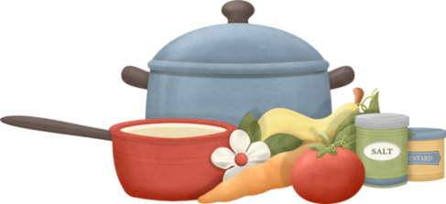
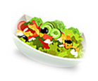
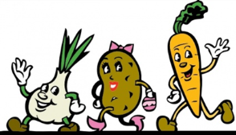
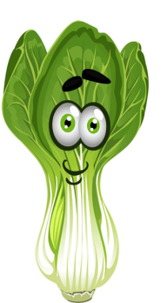



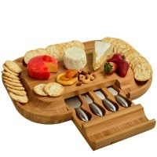

KULLANILAN MARKALAR/OUR SUPPLIERS: PINAR ET VE SÜT ÜRÜNLERİ/ DAIRY PRODUCTS, SÜTAŞ, BALPARMAK/HONNEY, KOR GEZEN TAVUK/FREE-RANGE CHICKEN,
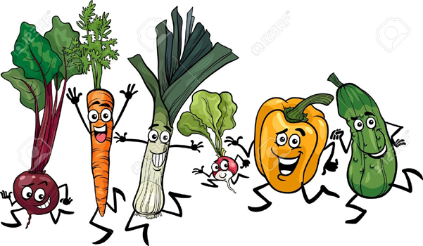
ATATÜRK ORMAN ÇİFTLİĞİ/DAIRY PRODUCTS, DOĞAL ZEYTİNYAĞI/NATURAL OLIVE OIL

EMİNE ÖZTÜRK
TAD PRESCHOOL MAVİŞEHİR
KURULUŞ MÜDÜRÜ

